**User’s Manual**

**HOW TO INSTALL XAMPP FOR WINDOWS?**

**STEP 1:** Open the XAMPP website. Go to <https://www.apachefriends.org/index.html> in your computer's web browser.

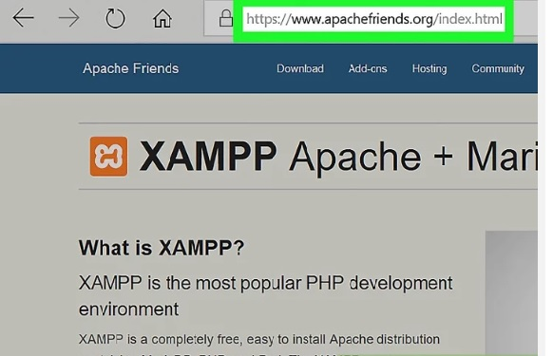

**STEP 2:** Click XAMPP for Windows. It's a grey button near the bottom of the page. Depending on your browser, you may first have to select a save location or verify the download.

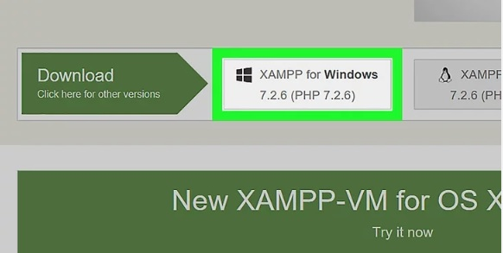

**STEP 3:** Double-click the downloaded file. This file should be named something like xampp-win32-7.2.4-0-VC15-installer, and you'll find it in the default downloads location (e.g., the "Downloads" folder or the desktop).

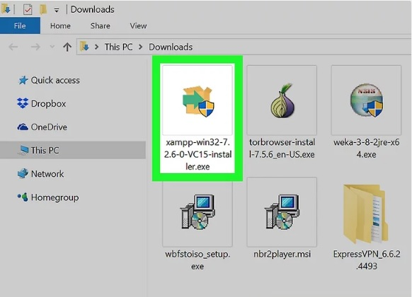

**STEP 4:** Click Yes when prompted. This will open the XAMPP setup window. You may have to click OK on a warning if you have User Account Control (UAC) activated on your computer.

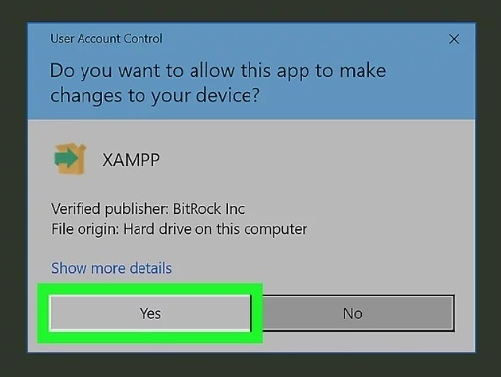

**STEP 5:** Click Next. It’s at the bottom of the setup window

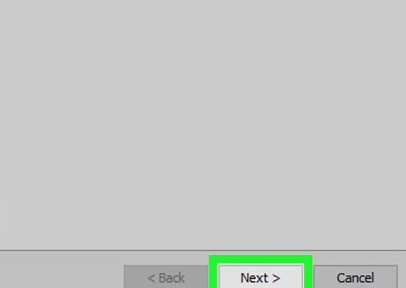

**STEP 6:** Select aspects of XAMPP to install. Review the list of XAMPP attributes on the left side of the window; if you see an attribute that you don't want to install as part of XAMPP, uncheck its box. By default, all attributes are included in your XAMPP installation.

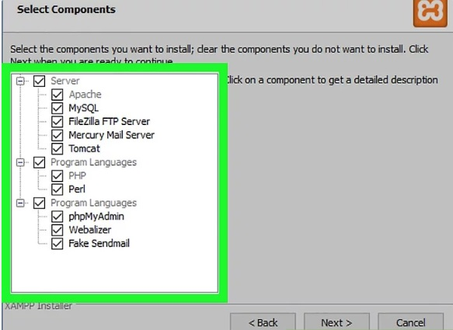

**STEP 7:** Click Next. It's at the bottom of the window.

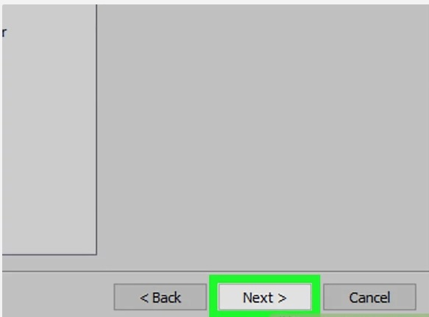

**STEP 8:** Select an installation location. Click the folder-shaped icon to the right of the current installation destination, then click a folder on your computer. If you have the UAC activated on your computer, avoid installing XAMPP in your hard drive's folder (e.g., OS (C:)). You can select a folder (e.g., Desktop) and then click Make New Folder to create a new folder and select it as the installation destination.

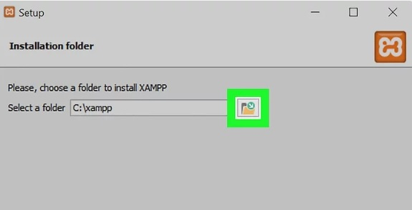

**STEP 9:** Click OK. Doing so confirms your selected folder as your XAMPP installation location.

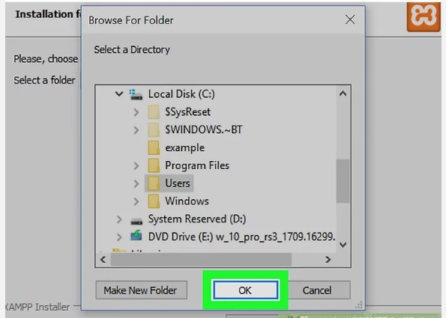

**STEP 10:** Click Next. You'll find it at the bottom of the page.

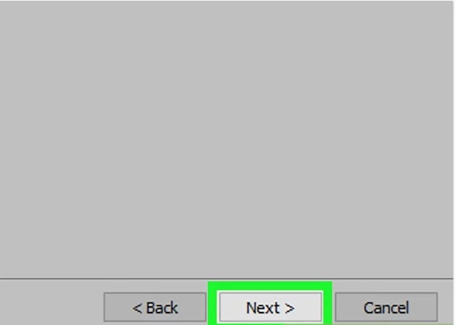

**STEP 11:** Uncheck the "Learn more about Bitnami" box, then click Next. The "Learn more about Bitnami" box is in the middle of the page.

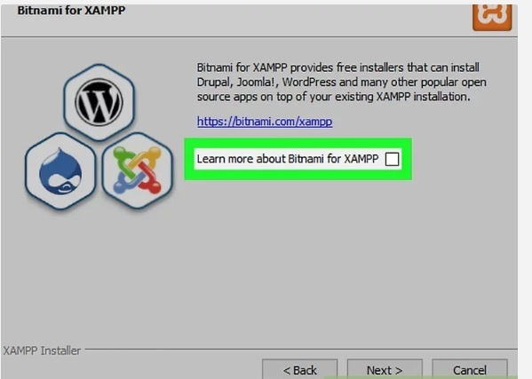

**STEP 12:** Begin installing XAMPP. Click Next at the bottom of the window to do so. XAMPP will begin installing its files into the folder that you selected.

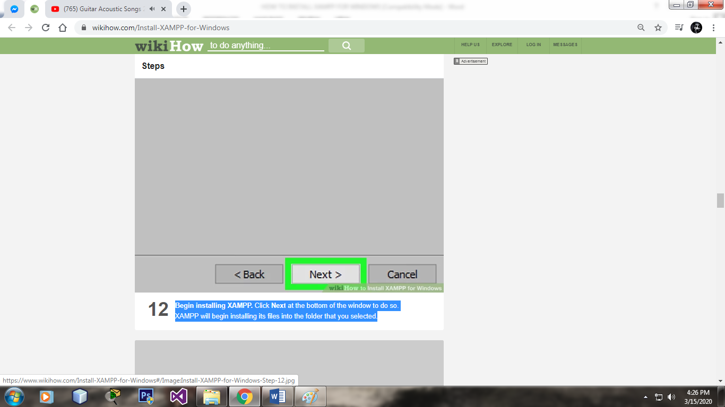

**STEP 13:** Click Finish when prompted. It's at the bottom of the XAMPP window. Doing so will close the window and open the XAMPP Control Panel, which is where you'll access your servers.

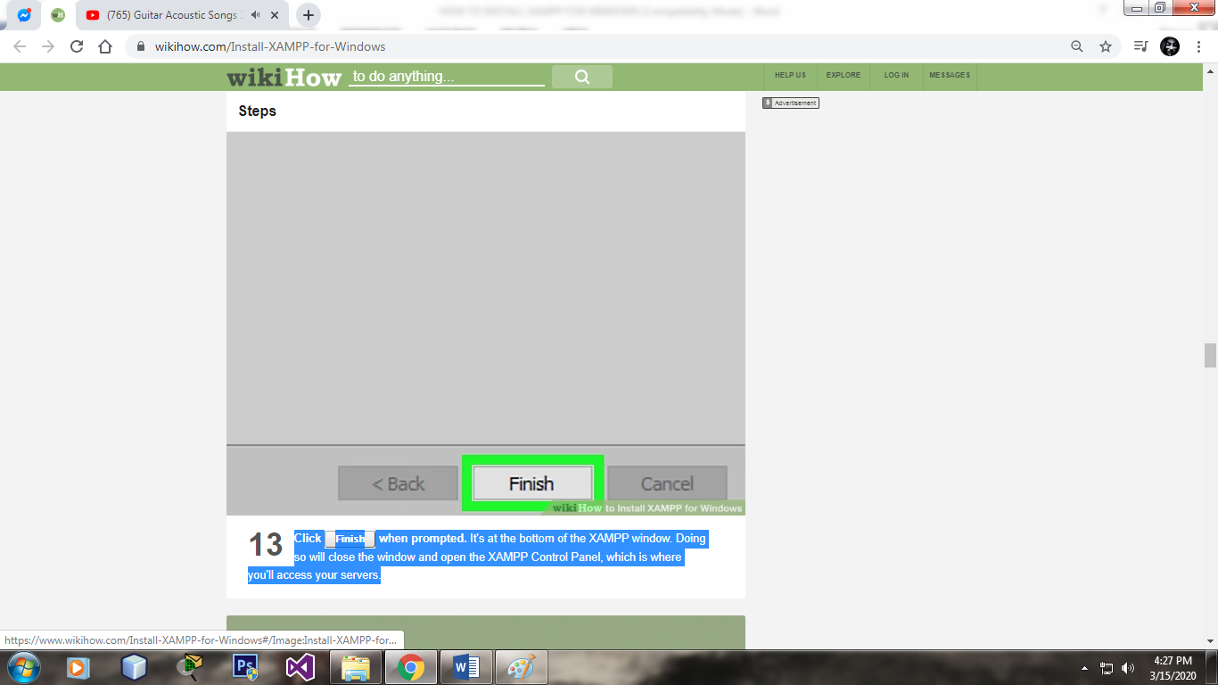

**STEP 14:** Select a language. Check the box next to the American flag for English, or check the box next to the German flag for German. lick Save. Doing so opens the main Control Panel page.

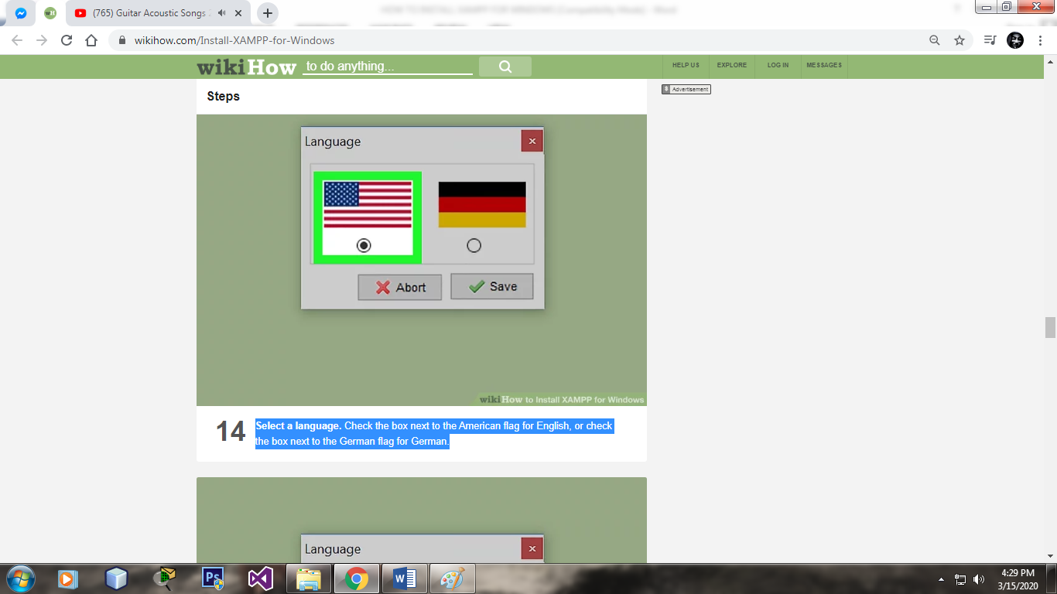

**STEP 15:** Start XAMPP from its installation point. If you need to open the XAMPP Control Panel in the future, you can do so by opening the folder in which you installed XAMPP, right-clicking the orange-and-white xampp-control icon, clicking Run as administrator, and clicking Yes when prompted. When you do this, you'll see red X marks to the left of each server type (e.g., "Apache"). Clicking one of these will prompt you to click Yes if you want to install the server type's software on your computer. Counterintuitively, double-clicking the xampp_start icon doesn't start XAMPP.

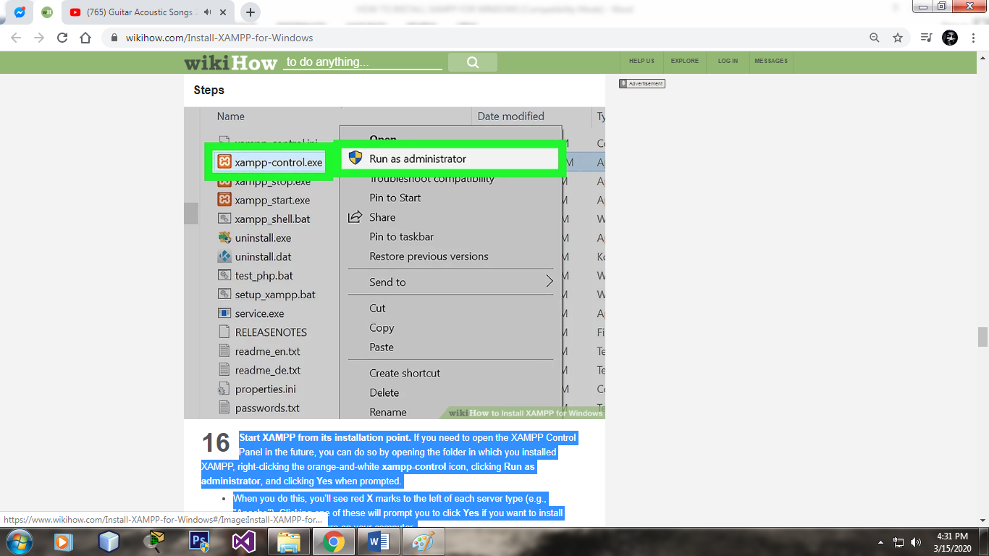

**STEP 16:** Resolve issues with Apache refusing to run. On some Windows 10 computers, Apache won't run due to a "blocked port". This can happen for a couple of reasons, but there's a relatively easy fix: Click Config to the right of the "Apache" heading. Click Apache (httpd.conf) in the menu. Scroll down to the "Listen 80" section (you can press Ctrl+F and type in listen 80 to find it faster). Replace 80 with any open port (e.g., 81 or 9080). Press Ctrl+S to save the changes, then exit the text editor. Restart XAMPP by clicking Quit and then re-opening it in administrator mode from its folder.

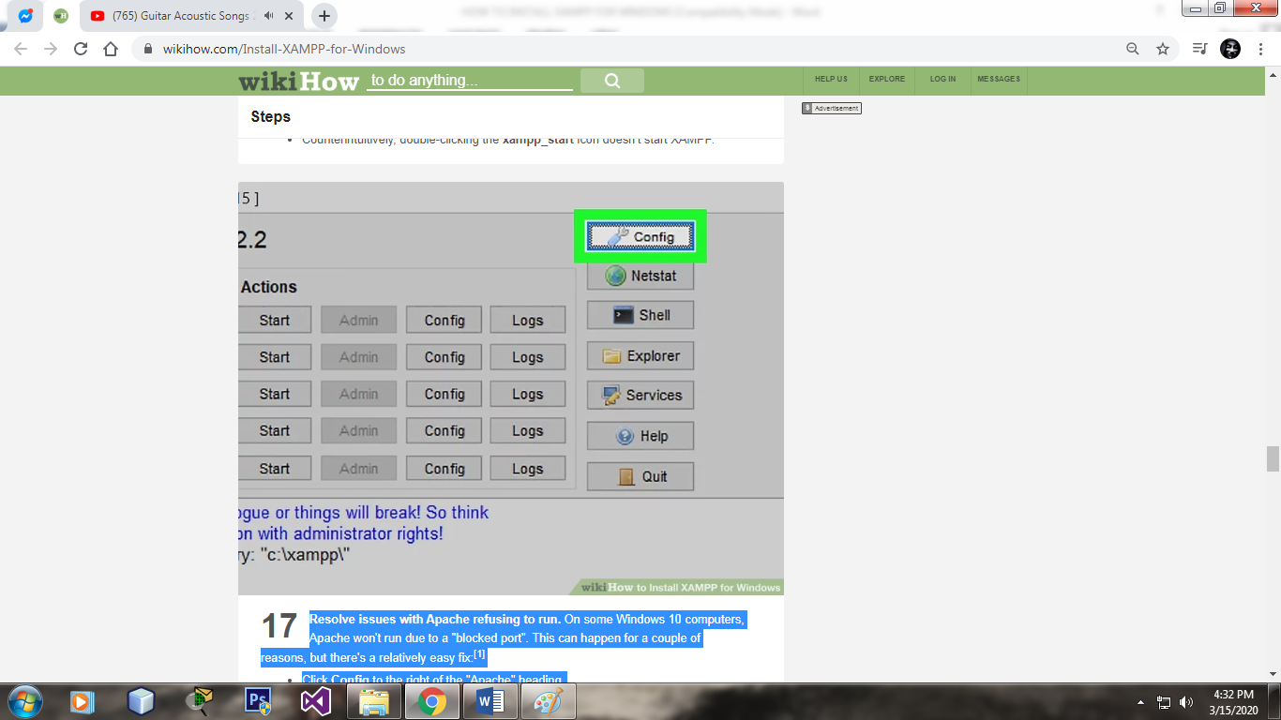

**HOW TO USE BARANGAY WEB-SYSTEM**

LOGIN

1. TYPE YOUR USERNAME AND PASSWORD
2. CLICK SIGN IN

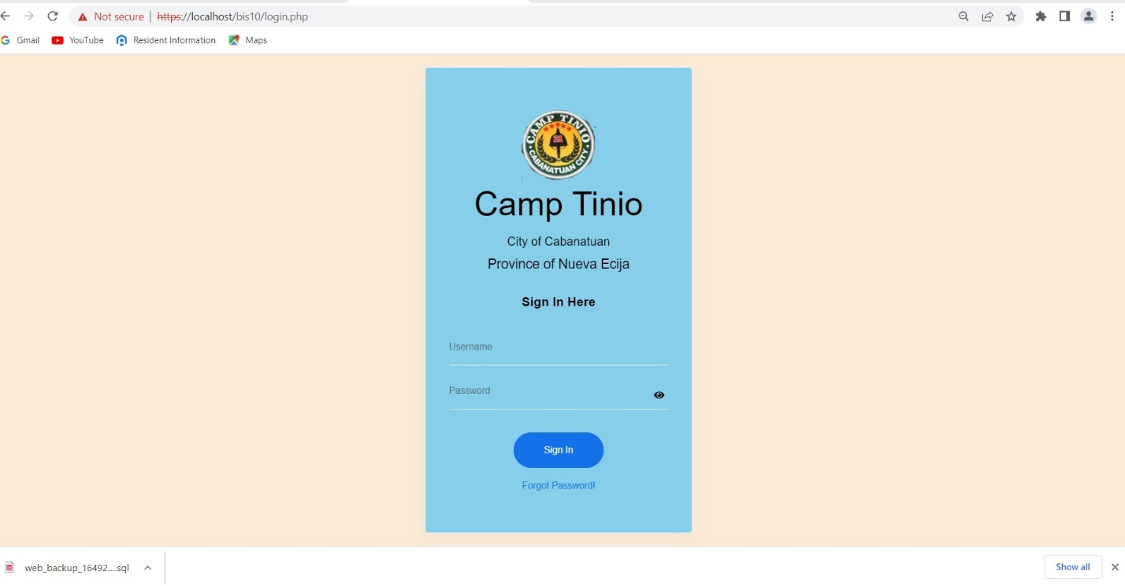

**BRIEF HISTORY**

THIS IS THE BRIEF HISTORY OF THE BARANGAY CAMP TINIO

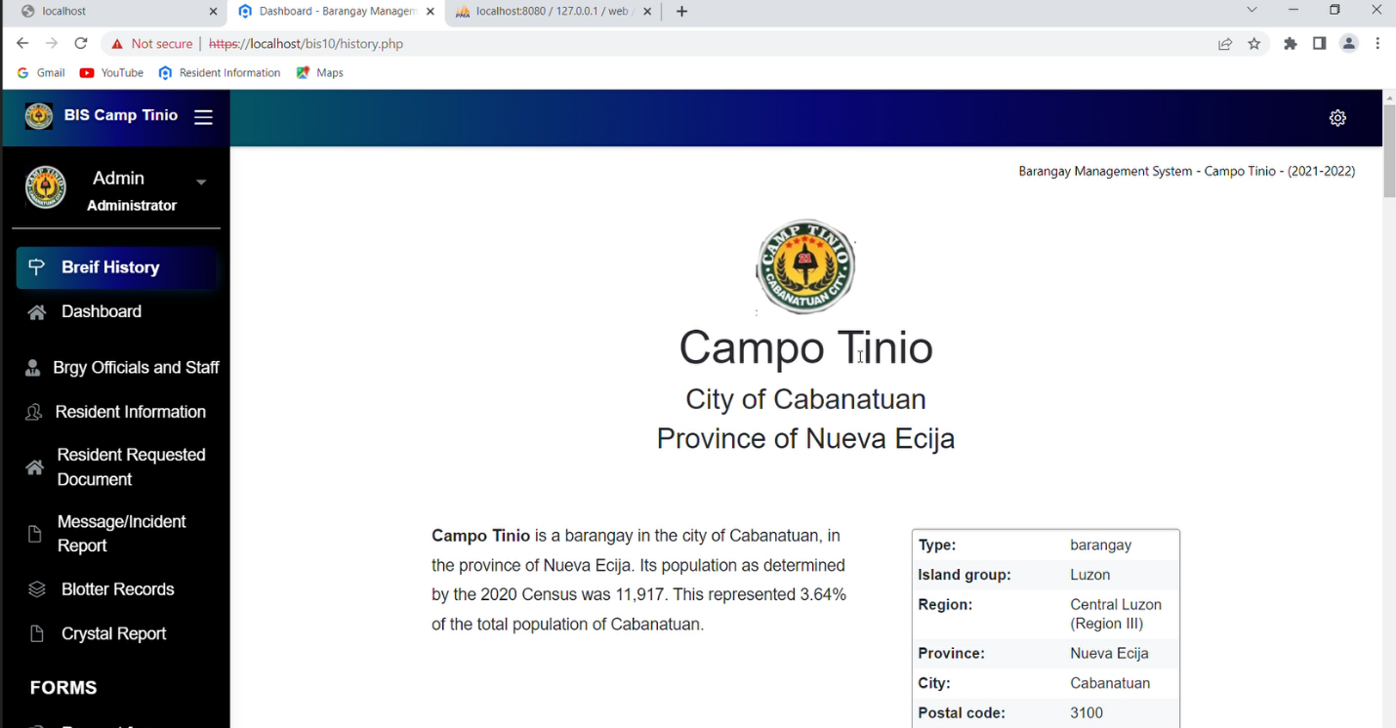

**DASHBOARD**

THIS IS THE DASHBOARD YOU CAN SEE ALL THE STATUS ABOUT BARANGAY CAMP TINIO RESIDENTS

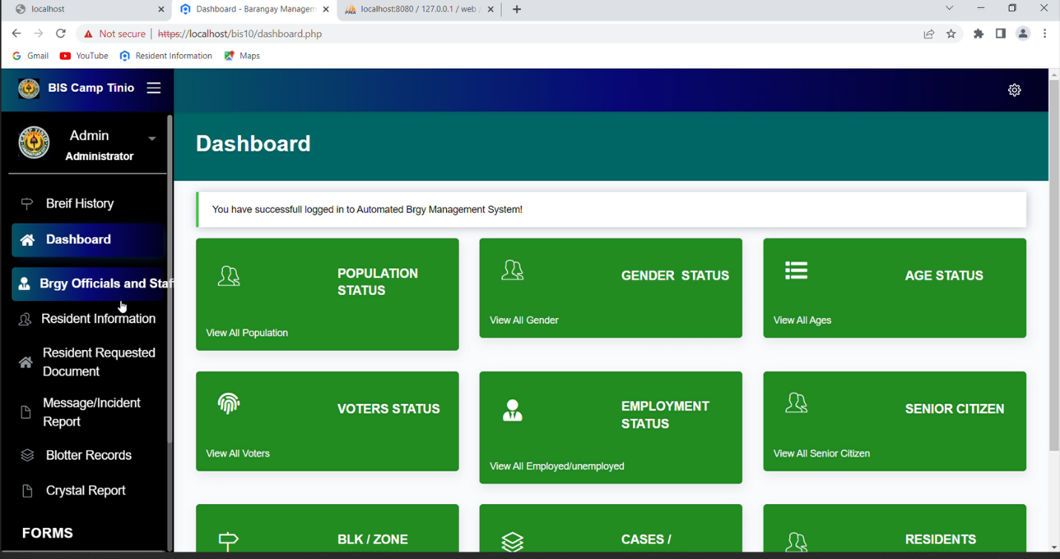

**RESIDENTS INFORMATION**

THIS IS THE RESIDENT INFORMATION YOU CAN ADD, EDIT, GENERATE, REMOVE RESIDENTS

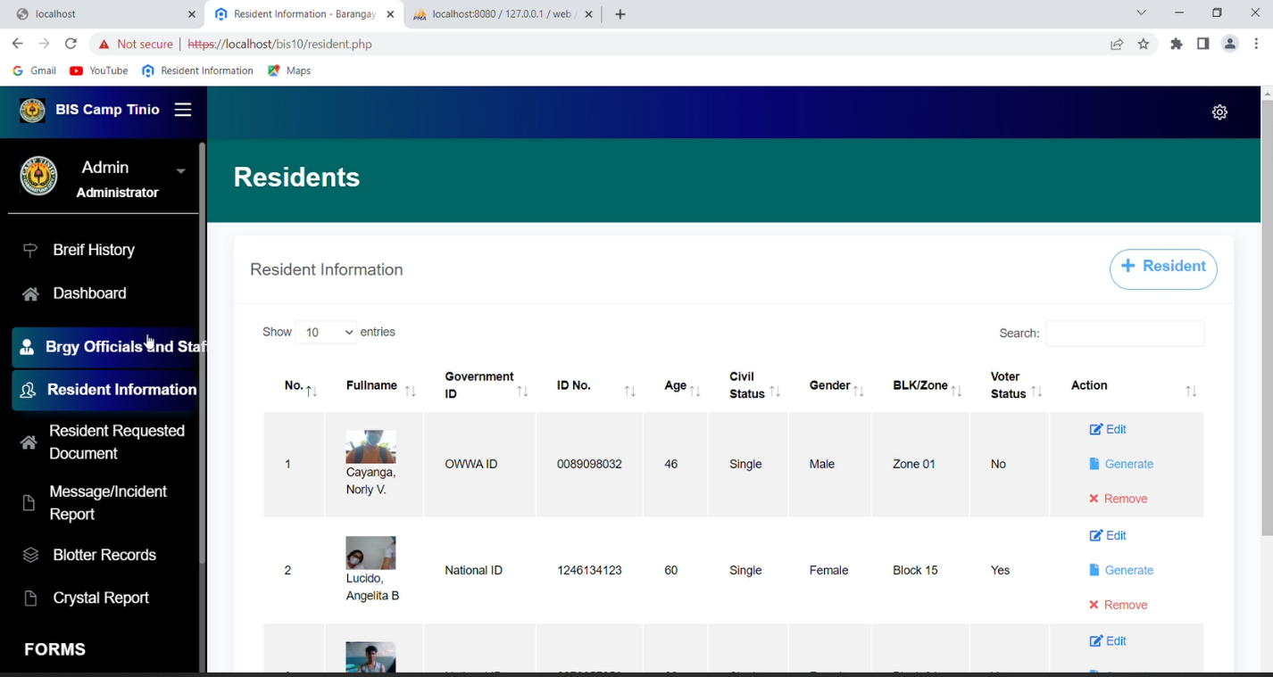

**POPULATION STATUS**

YOU CAN SEE ALL RESIDENTS OF CAMP TINIO

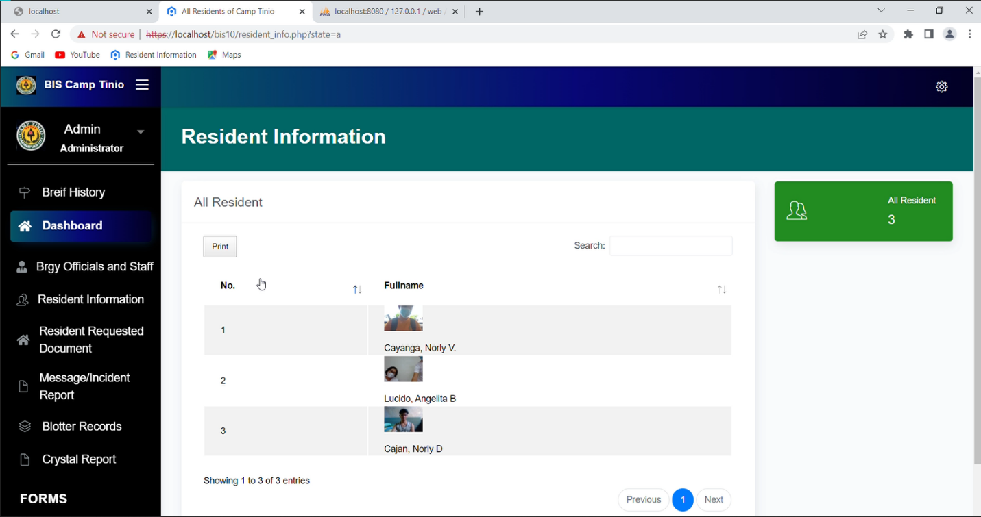

**GENDER STATUS**

YOU CAN SEE ALL MALE AND FEMALE RESIDENTS OF CAMP TINIO

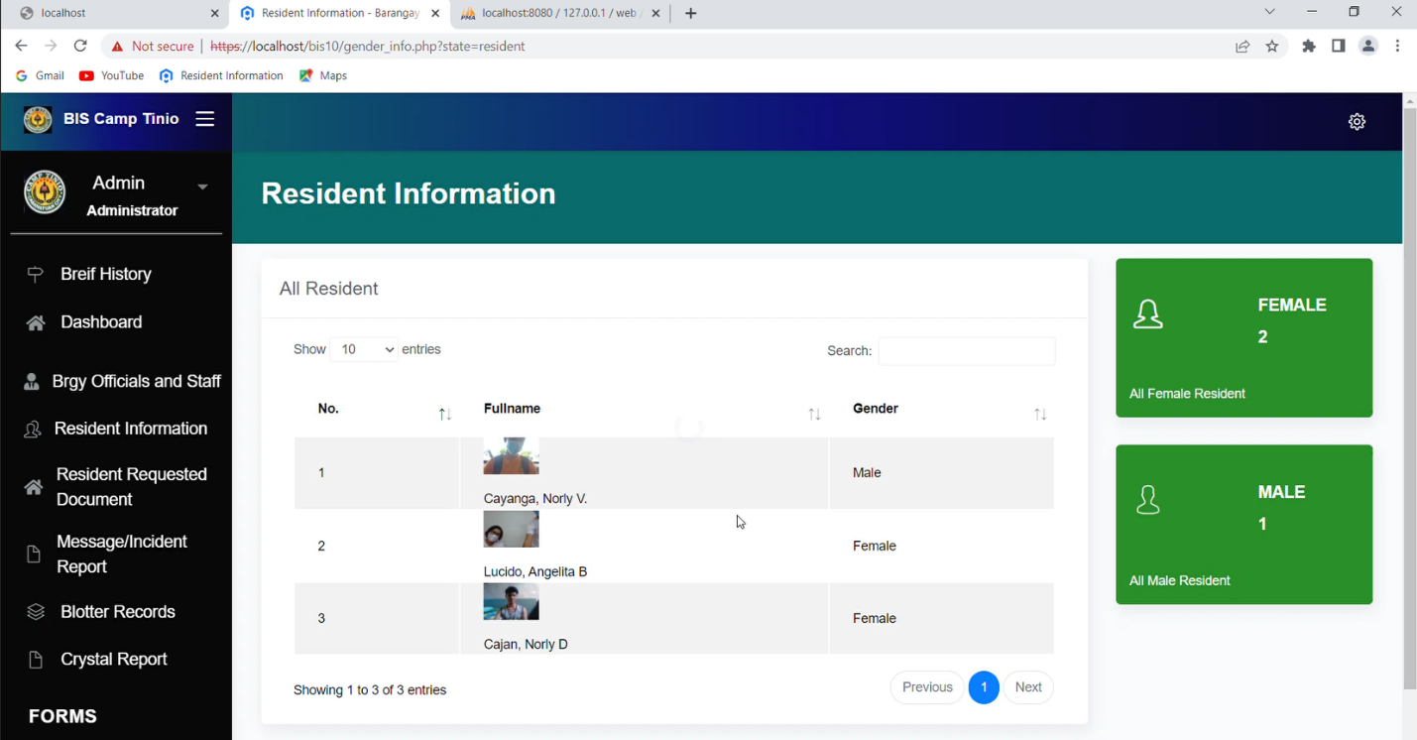

**AGE STATUS**

YOU CAN SEE THE AGE BRACKET OF THE RESIDENTS OF CAMP TINIO

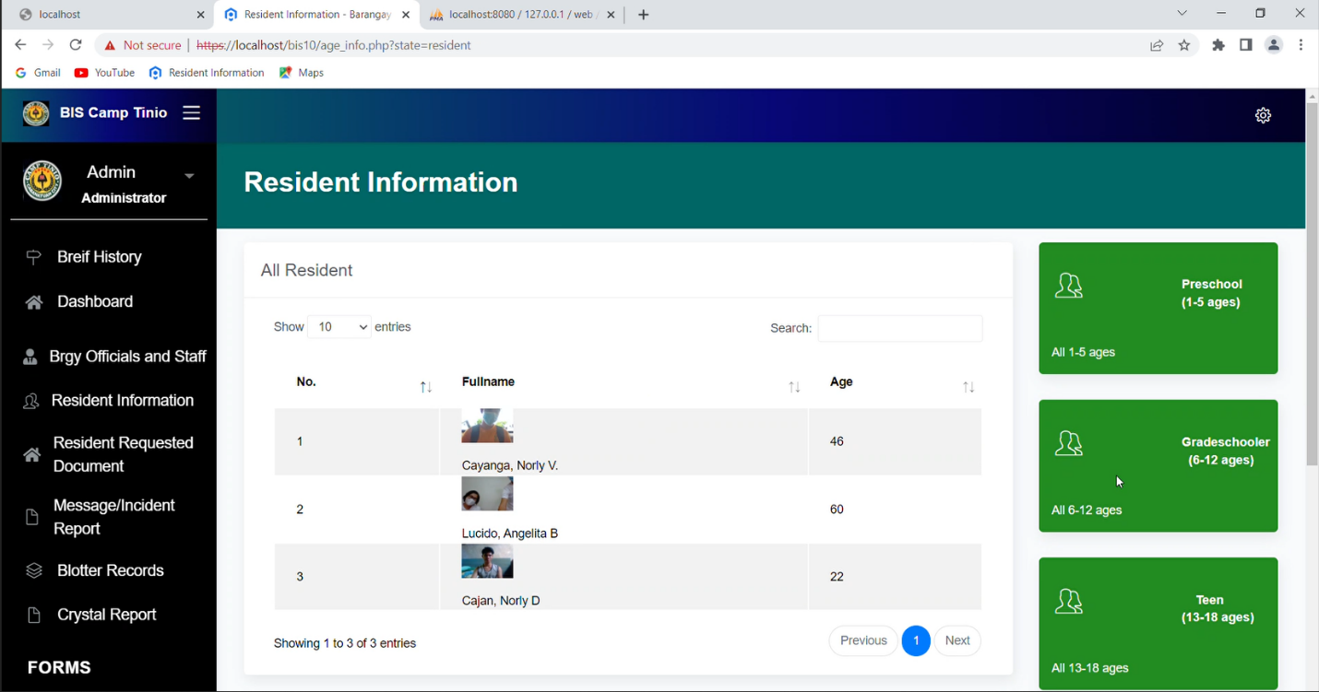

**SENIOR CITIZEN**

YOU CAN SEE THE ALL SENIOR CITIZEN IN THE BARANGAY CAMP TINIO

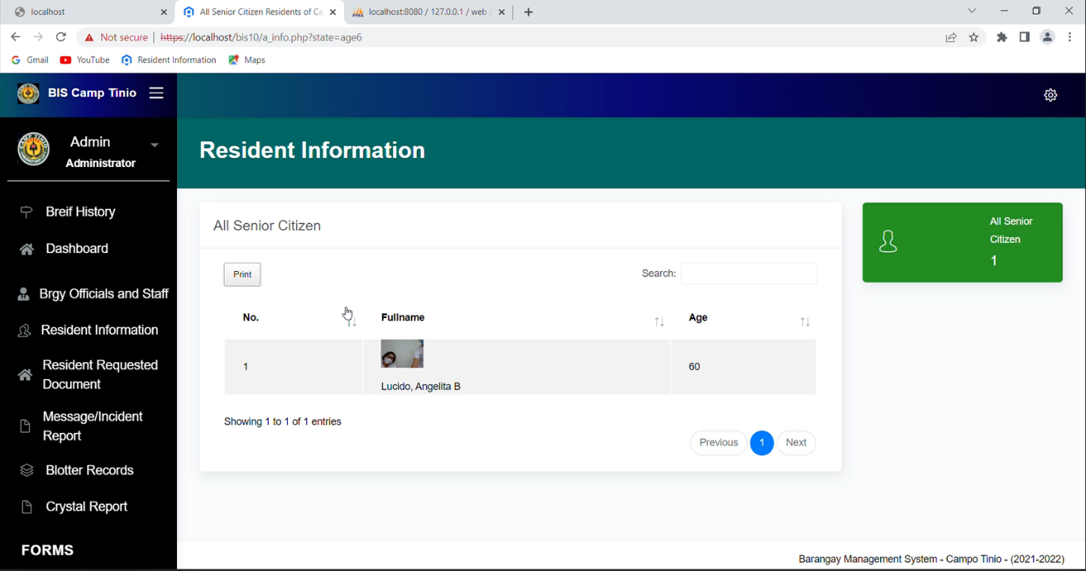

**VOTERS STATUS**

YOU CAN SEE THE ALL REGISTERED VOTERS AND NON VOTERS IN THE BARANGAY CAMP TINIO

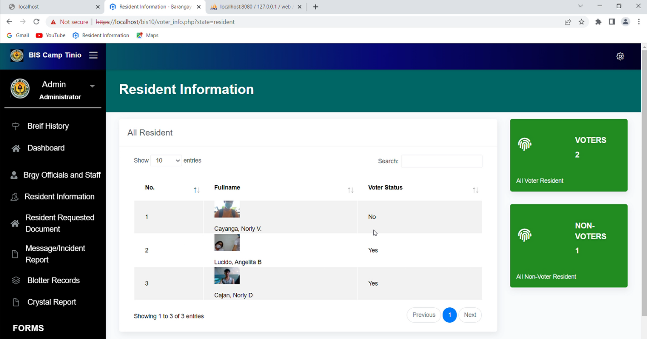

**EMPLOYEMENT STATUS**

YOU CAN SEE THE EMPLOYMENT STATUS OF THE RESIDENTS OF BARANGAY CAMP TINIO

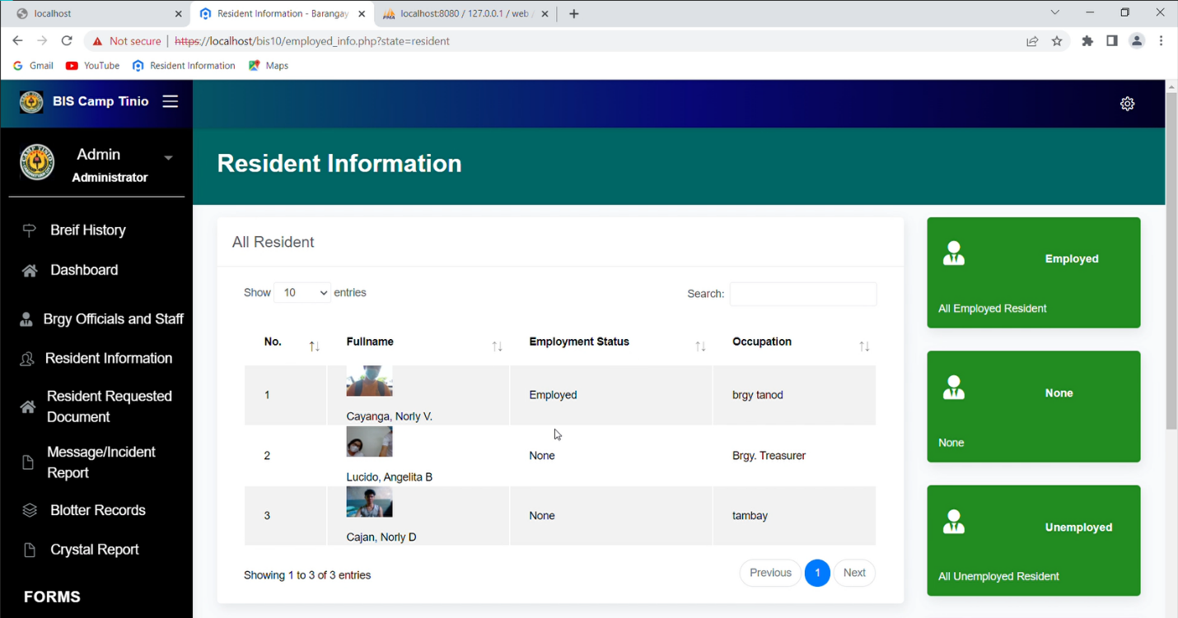 **BLK/ZONE**

THIS IS THE BLK/ ZONE OF THE BARANGAY CAMP TINIO

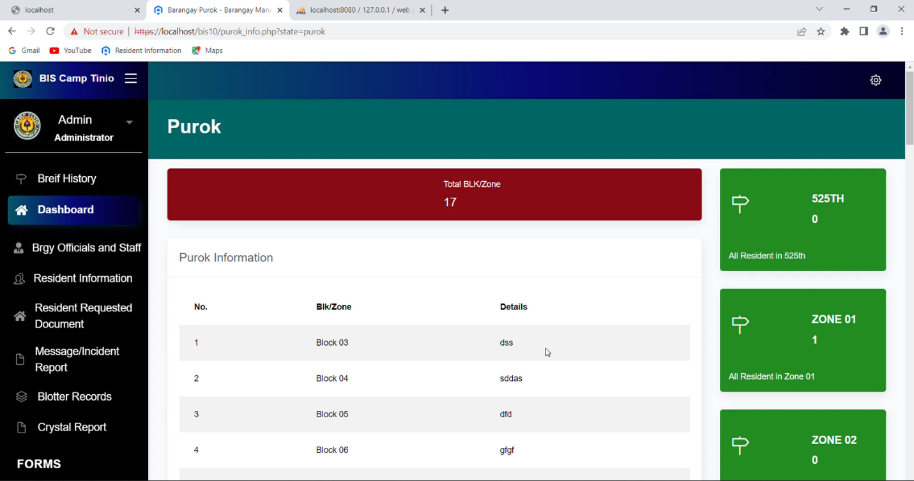

**BLOTTER/INCIDENT REPORT**

YOU CAN ADD, EDIT AND PRINT BLOTTER/INCIDENT REPORT

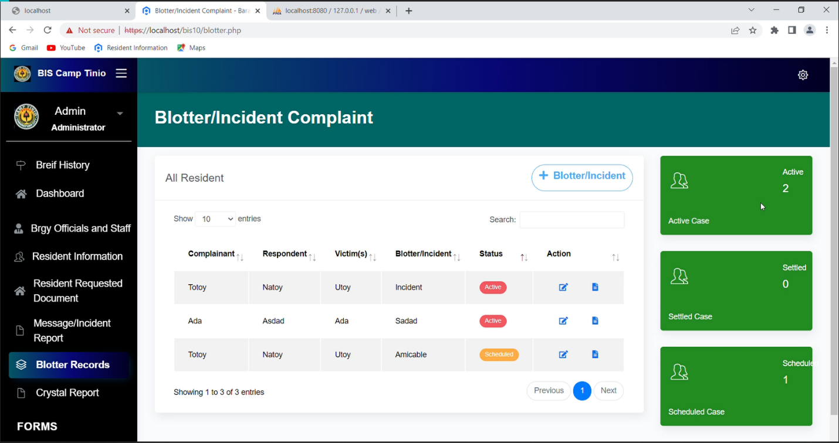

**RESIDENTS STATUS**

YOU CAN SEE ALL RESIDENTS STAUS

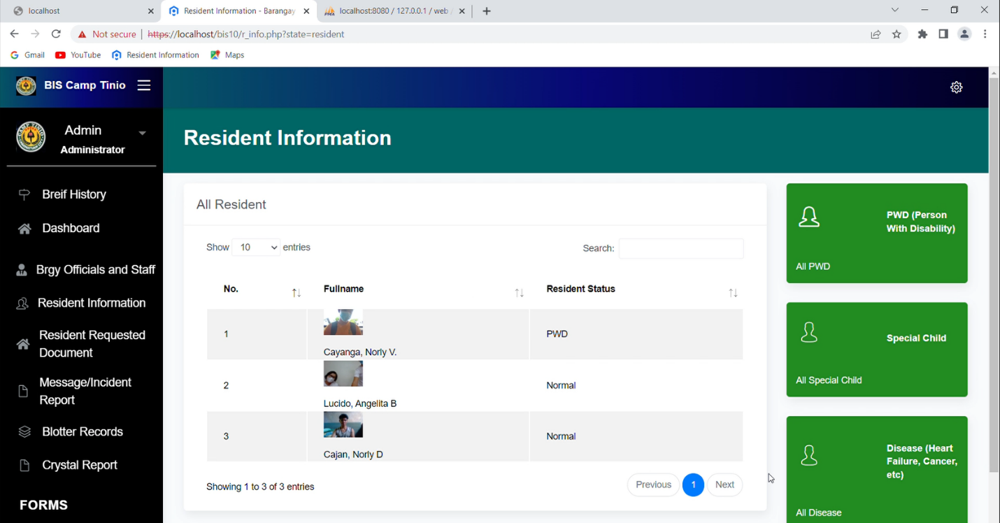

**RESIDENT REQUESTED DOCUMENT**

THIS IS THE REQUEST LIST OF THE RESIDENTS

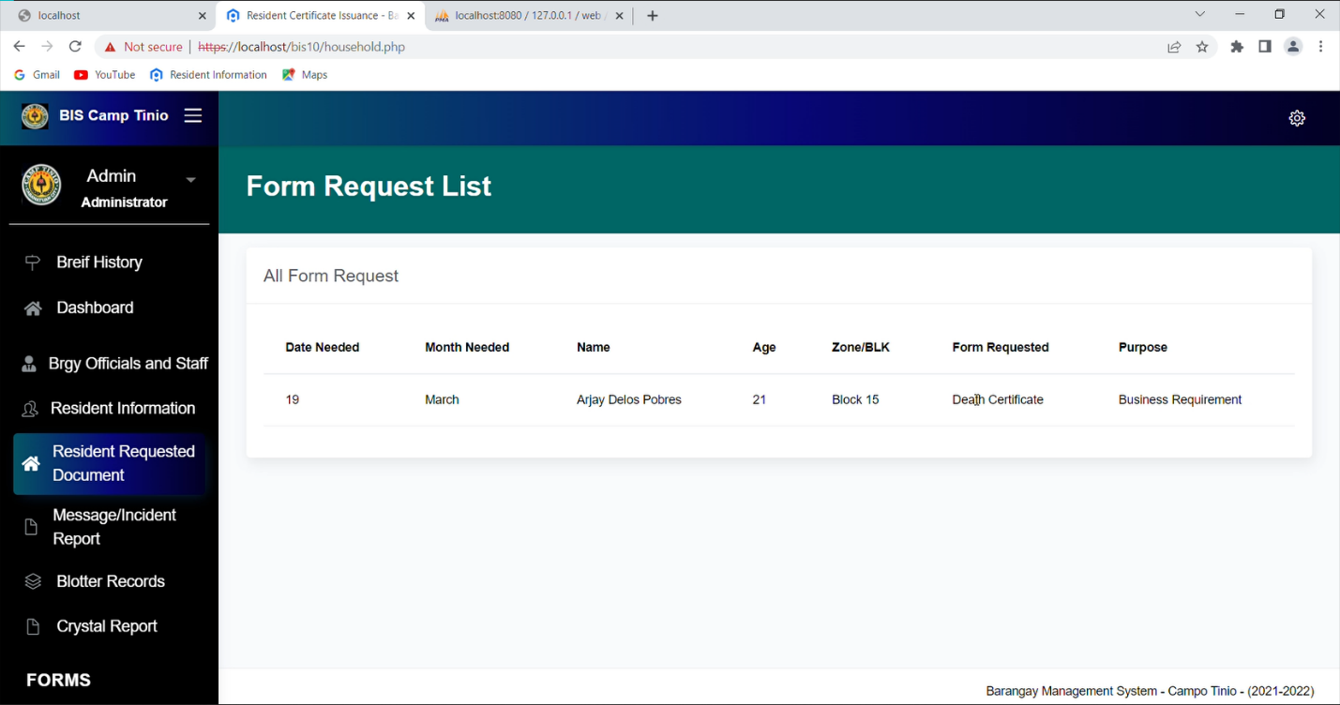

**MESSAGE/INCIDENT REPORT**

THIS IS THE MESSAGE/ INCIDENT REPORT OF THE RESIDENTS

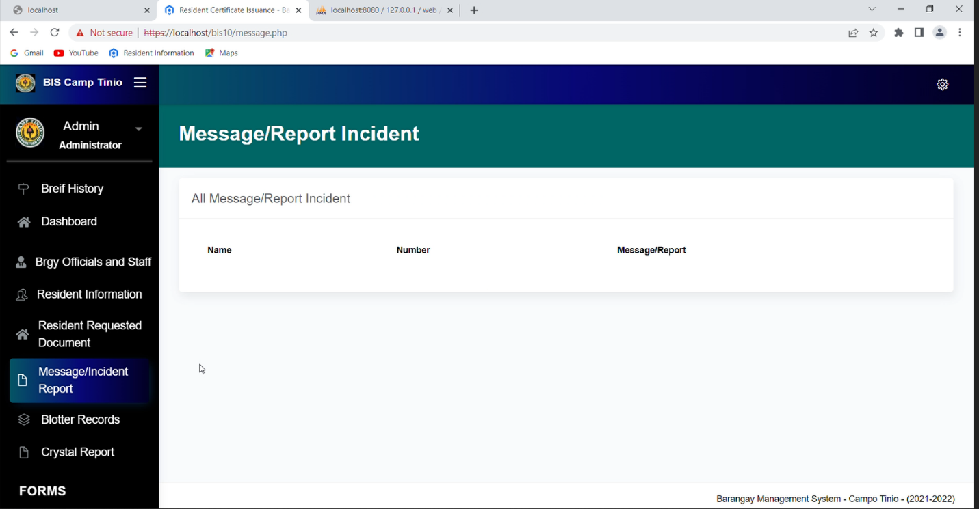

**CRYSTAL REPORTS**

**THIS IS THE BARANGAY CRYSTAL REPORTS**

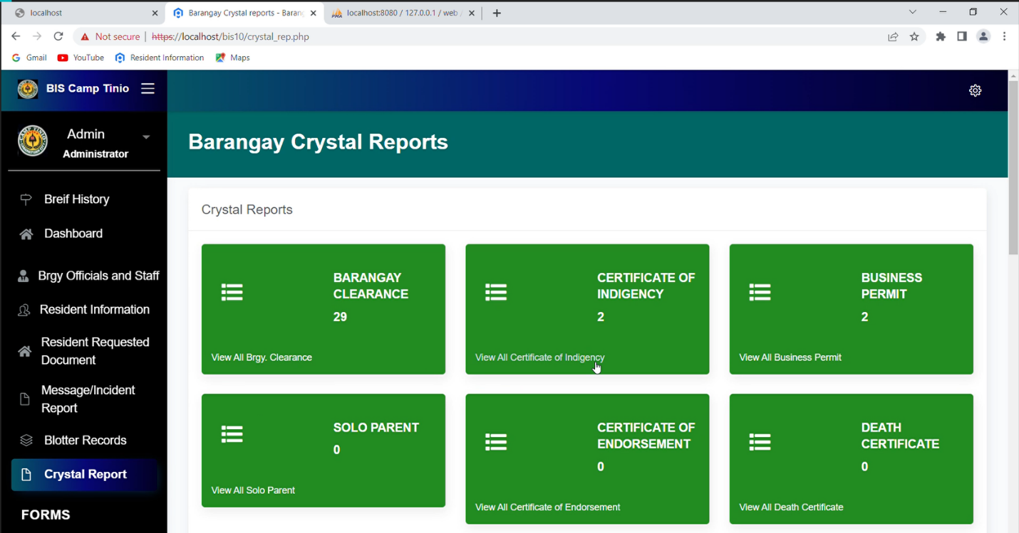

**BARANGAY CLEARANCE**

YOU CAN GENERATE BARANGAY CLEARANCE

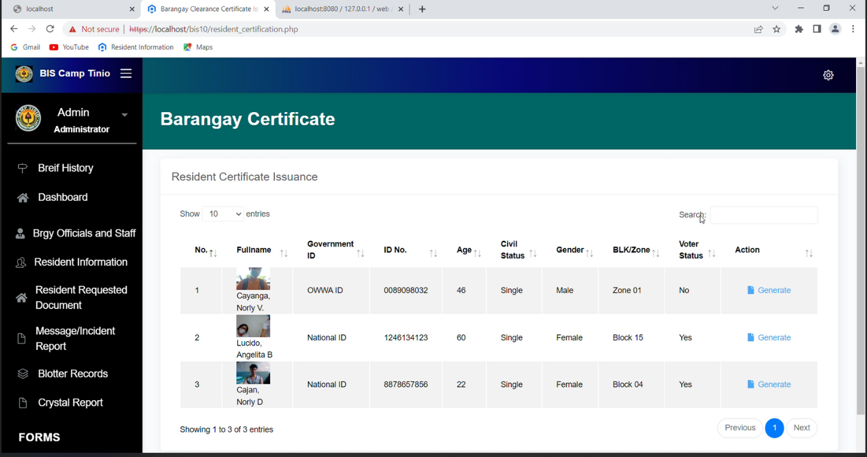

**CERTIFICATE OF INDIGENCY**

YOU CAN GENERATE CERTIFICATE OF INDIGENCY

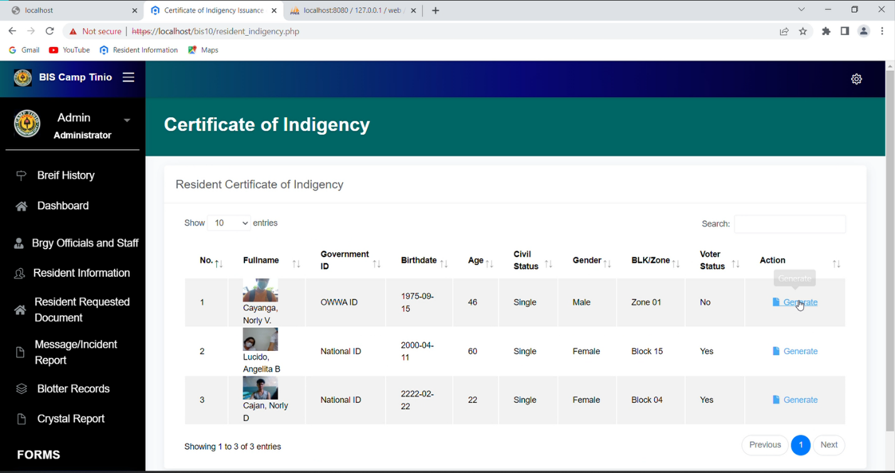

**BUSINESS PERMIT**

YOU CAN GENERATE BUSINESS PERMIT

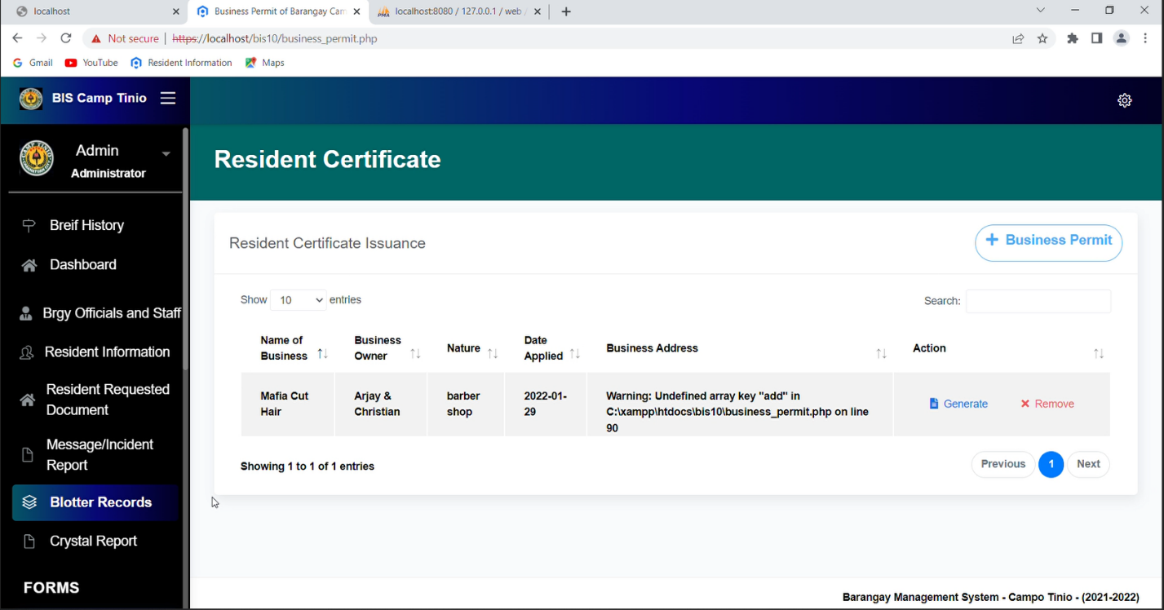

**BARANGAY INFO**

THIS IS THE BARANGAY INFO

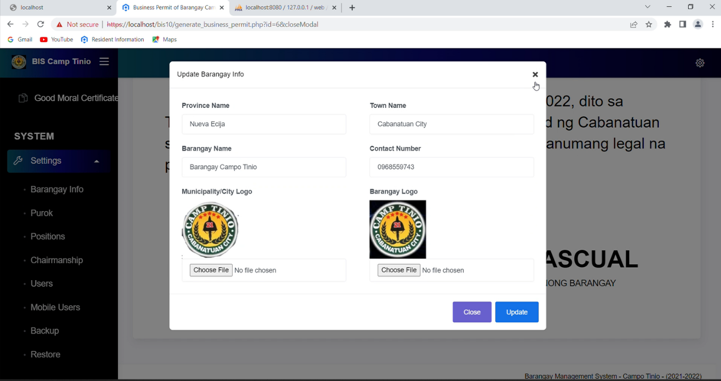

**BARANGAY BLK/ZONE**

YOU CAN ADD, EDIT, AND REMOVE BARANGAY BLK/ZONE

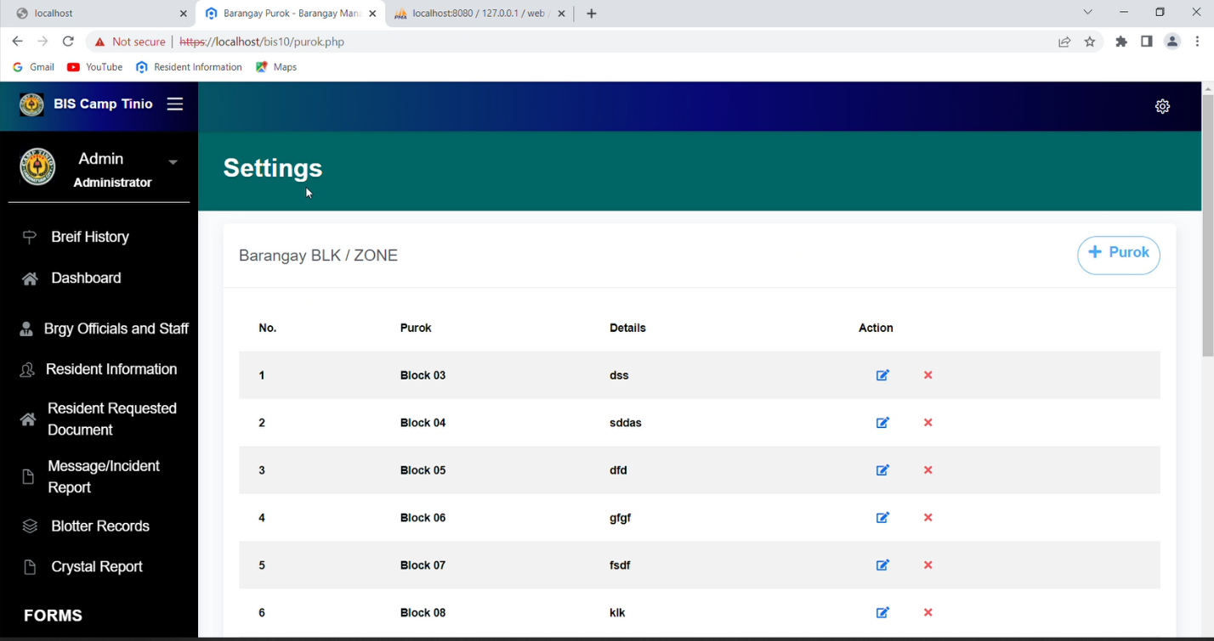

**WEB USERS**

THIS IS THE ALL WEB USERS, YOU CAN ADD AND REMOVE USER

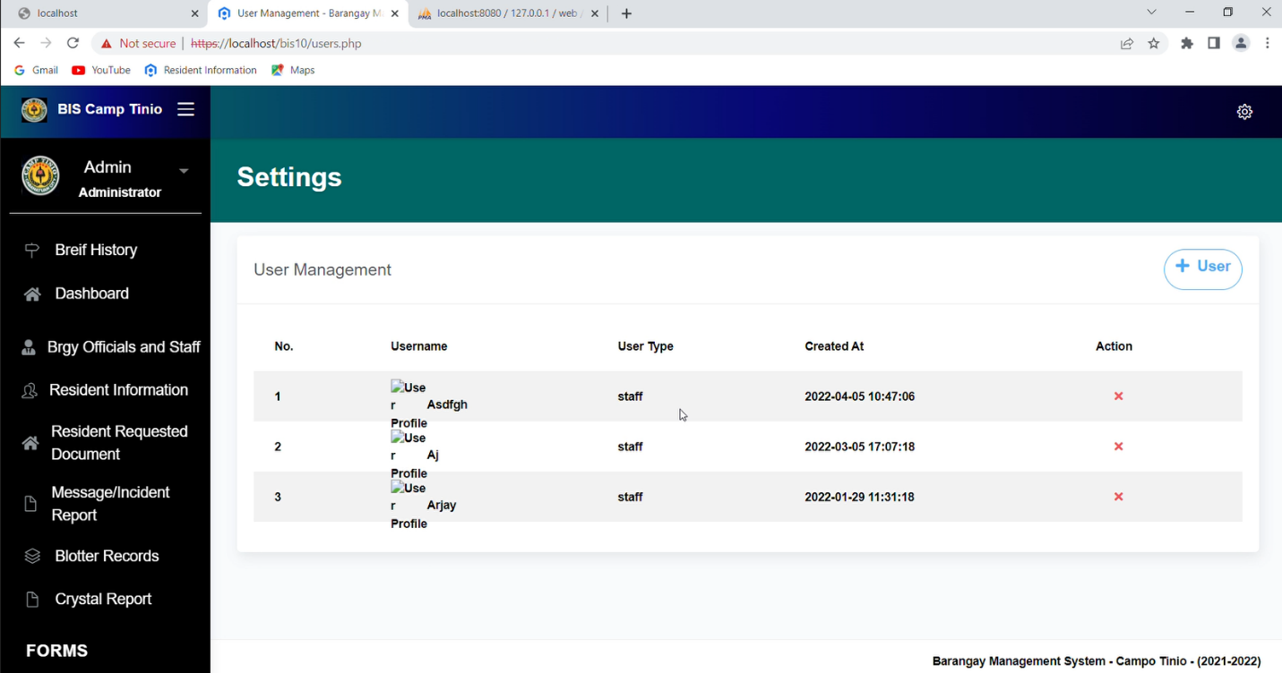

**MOBILE USERS**

THIS IS THE MOBILE USERS THAT ARE LOGIN IN THE MOBILE APPLICATION

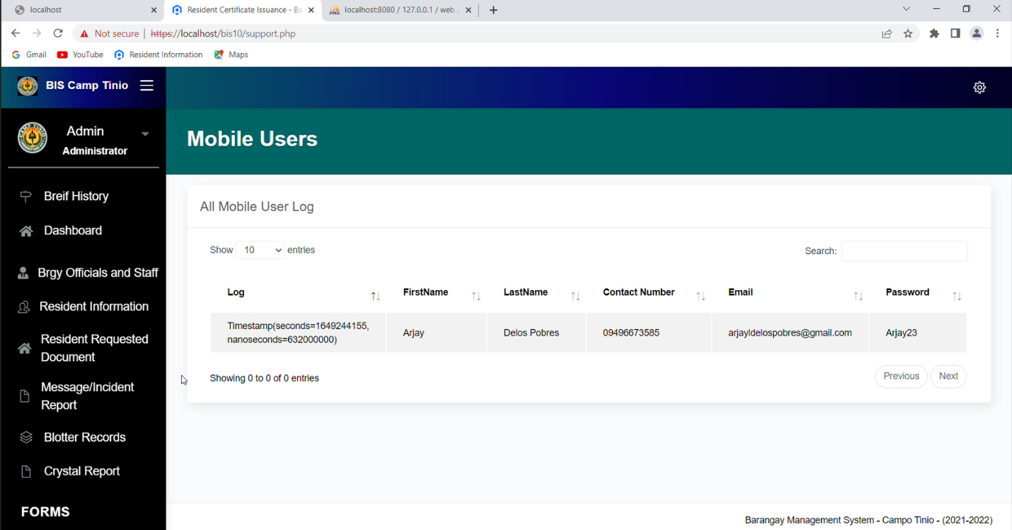

**BACKUP**

THIS IS FOR BACKUP THE INFORMATION OF THE BARANGAY CAMP TINIO

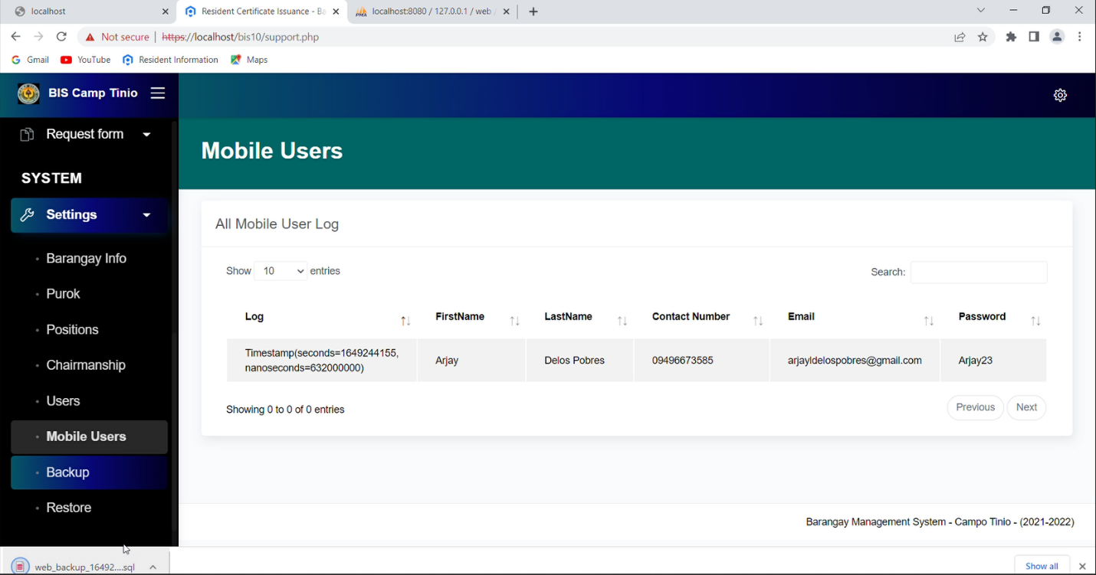

**RESTORE DATABSE**

THIS IS FOR RESTORE DATABASE

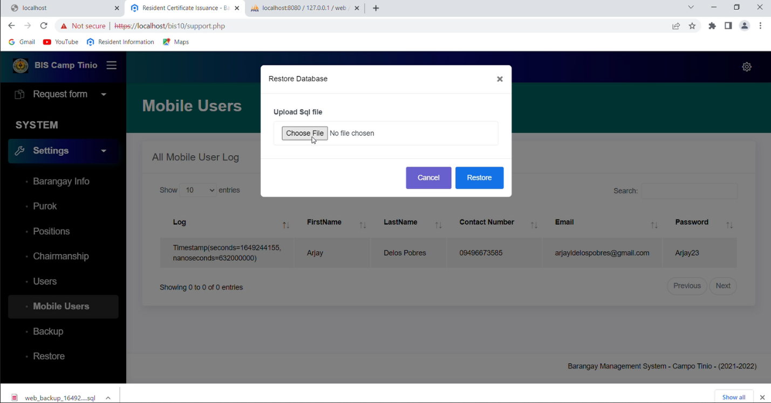

**FOR MOBILE APPLICATION**

**How to Install and set up Android Studio on Windows**

Step 1: Click this link <https://developer.android.com/studio/#downloads> to get the Android Studio executable or zip file.

Step 2: Click on the Download Android Studio Button.

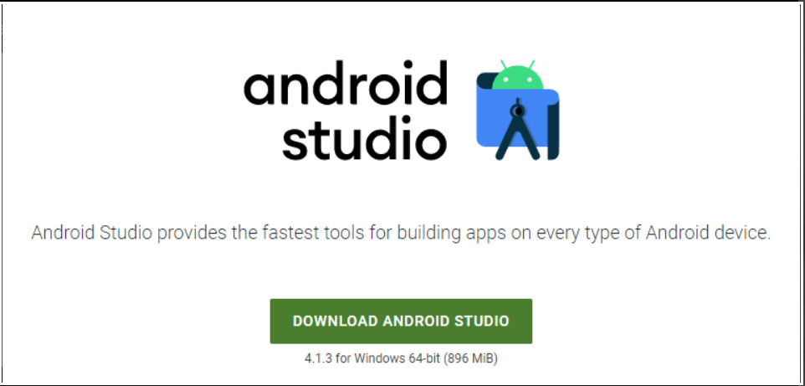

Click on the “I have read and agree with the above terms and conditions” checkbox followed by the download button.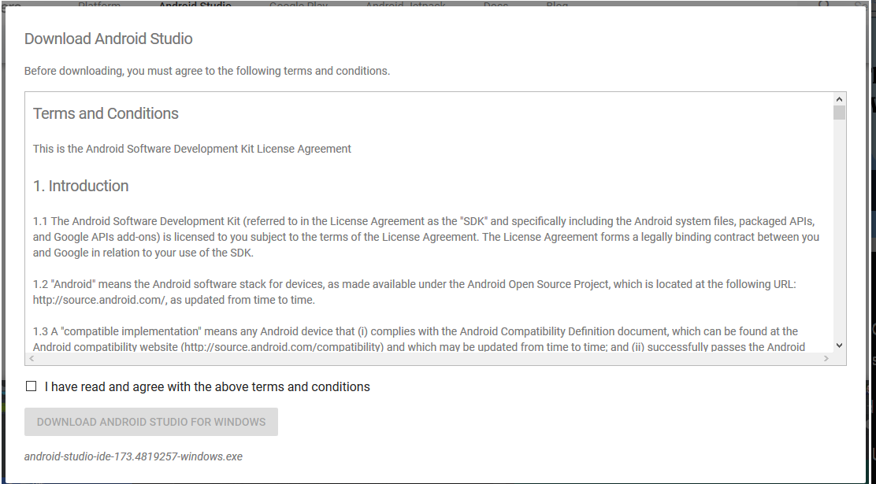

Click on the Save file button in the appeared prompt box and the file will start downloading.

Step3. After the downloading has finished, open the file from downloads and run it. It will prompt the following dialog box.

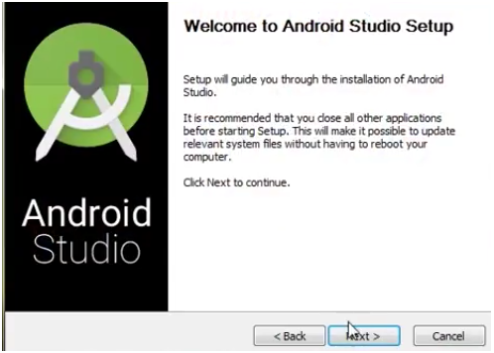

Click on next. In the next prompt, it’ll ask for a path for installation. Choose a path and hit next.

Step 4: It will start the installation, and once it completed, it will be like the image shown below.

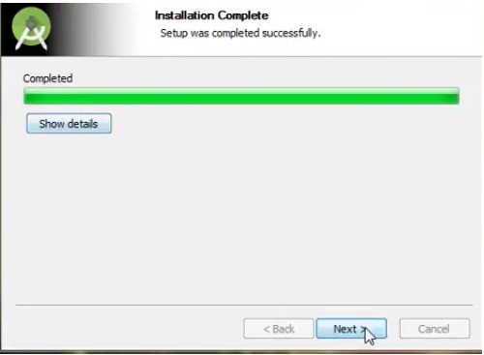

Click on next.

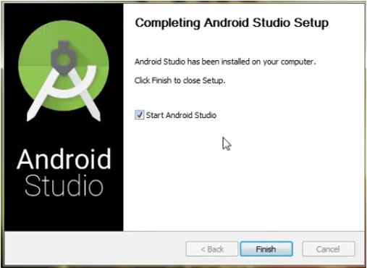

Step: Once “Finish” is clicked, it will ask whether the previous settings need to be imported [if the android studio had been installed earlier], or not. It is better to choose the ‘Don’t Import Settings option’.

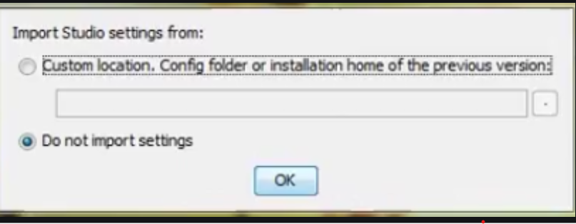

Click the OK button.

Step 6: This will start the Android Studio.

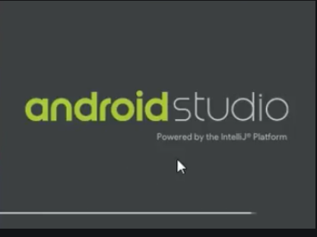

Meanwhile, it will be finding the available SDK components.

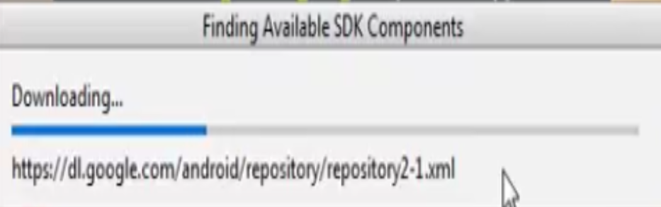

Step 7: After it has found the SDK components, it will redirect to the Welcome dialog box.

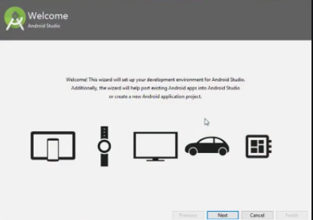

Click on Next.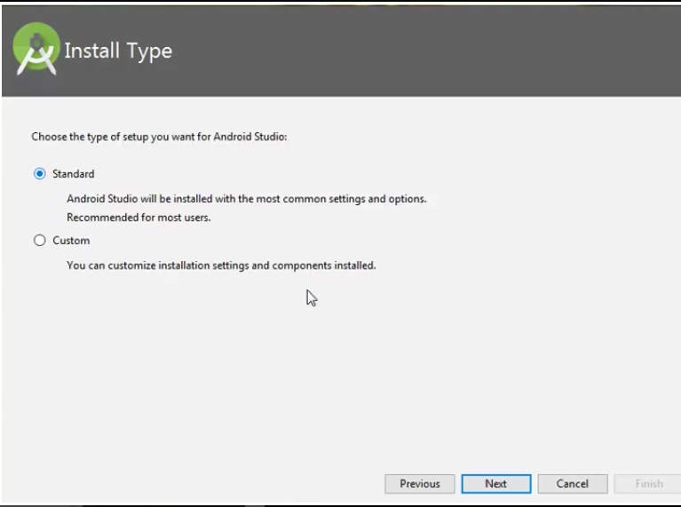 Choose Standard and click on next. Now choose the theme, whether the Light theme or the Dark one. The light one is called the IntelliJ theme whereas the dark theme is called Darcula. Choose as required.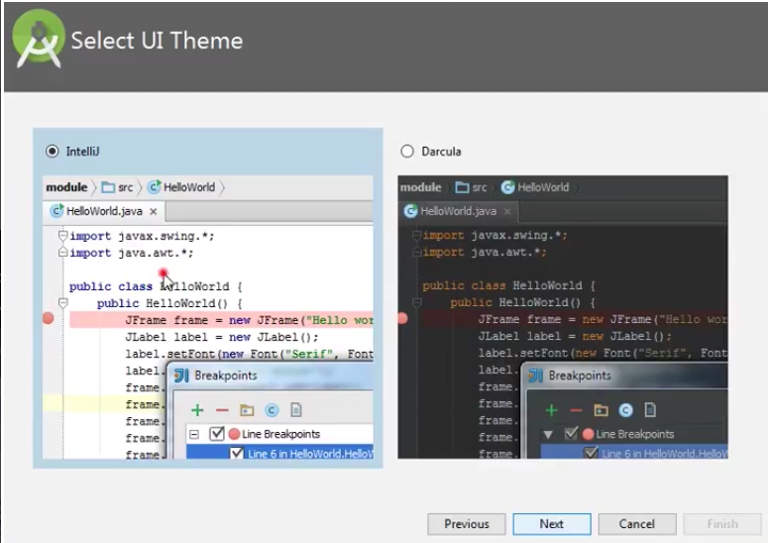Click on the Next button.

Step 8: Now it is time to download the SDK components.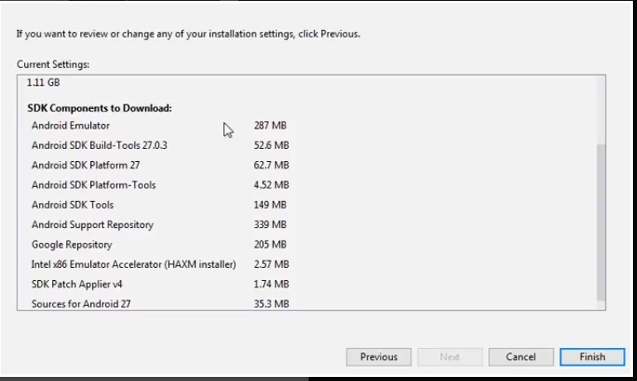

Click on Finish. Components begin to download let it complete.

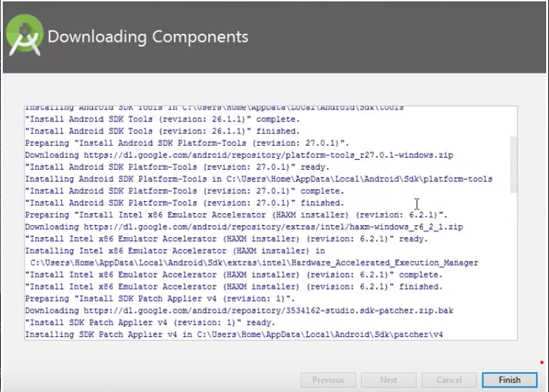The Android Studio has been successfully configured. Now it’s time to launch and build apps. Click on the Finish button to launch it.

Step 9: Click on Start a new Android Studio project to build a new app.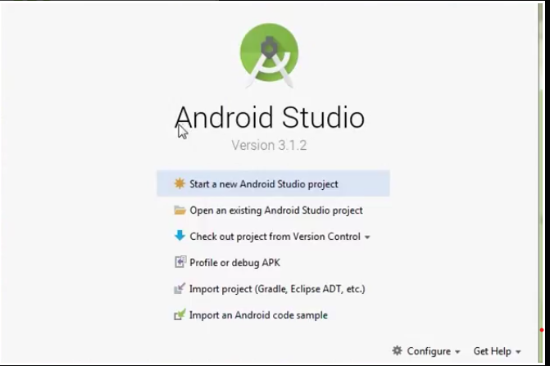

Click on Finish. Components begin to download let it complete.

**HOW TO USE RESIDENTS MOBILE APPS**

SPLASH ACTIVITY

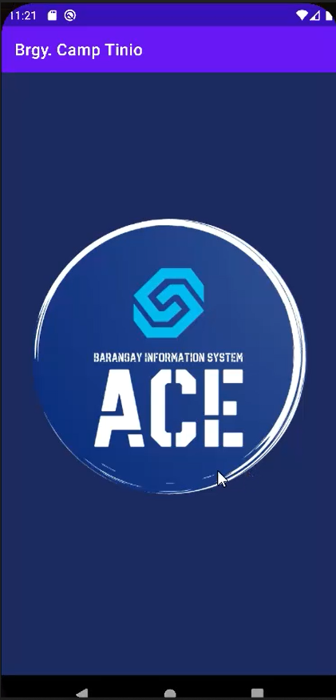

**SIGNUP**

1. THE USER WILL TYPE THE ASSIGNED FIRST NAME, LAST NAME, CONTACT NO., EMAIL, PASSWORD
2. IF YOU HAVE FINISHED CLICK CREATE

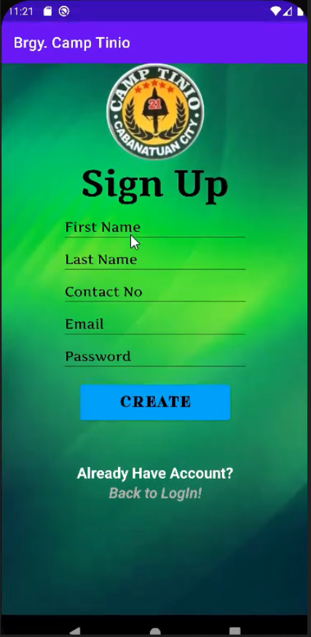

**LOGIN**

1. THE USER WILL TYPE THE ASSIGNED EMAIL
2. THE USER WILL TYPE THE ASSIGNED PASSWORD
3. IF YOU HAVE FINISHED CLICK LOGIN

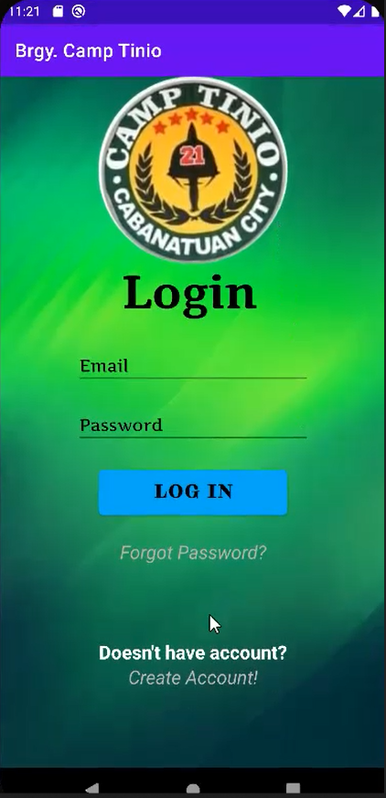

**RECAPTCHA**BEFORE YOU ACCESS YOU NEED TO ANSWER RECAPTCHA FOR SECURITY

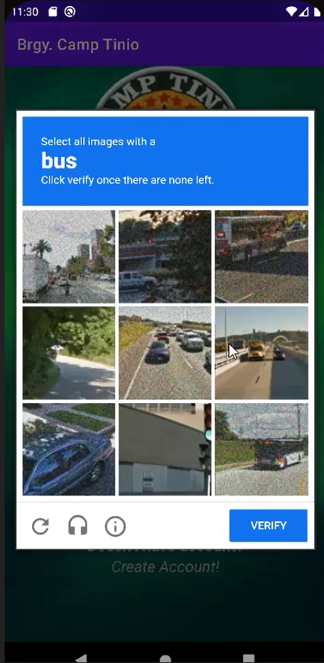

**BRIEF HISTORY**

THIS IS THE PAST RECORD OF THE BARANGAY ACCORDING TO PHILATLAS

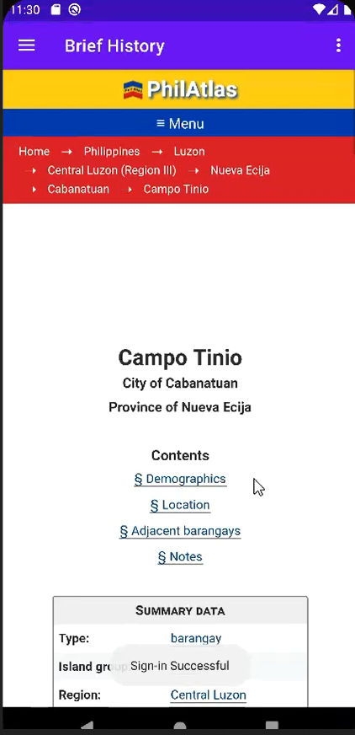

**MESSAGE/INCIDENT REPORT**

THIS IS FOR THE RESIDENT TO MESSAGE OR REPORT INCIDENT TO THE BARANGAY

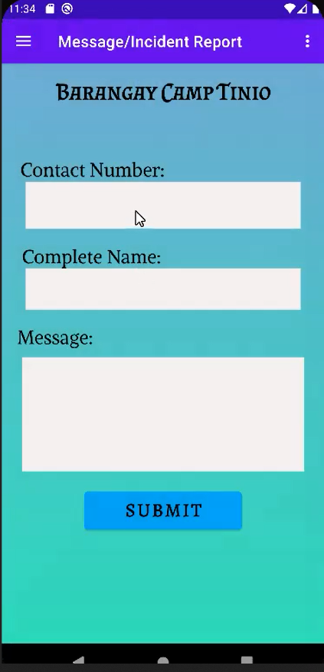

**REQUEST CERTIFICATES**

THIS IS FOR RESIDENTS REQUEST FORM

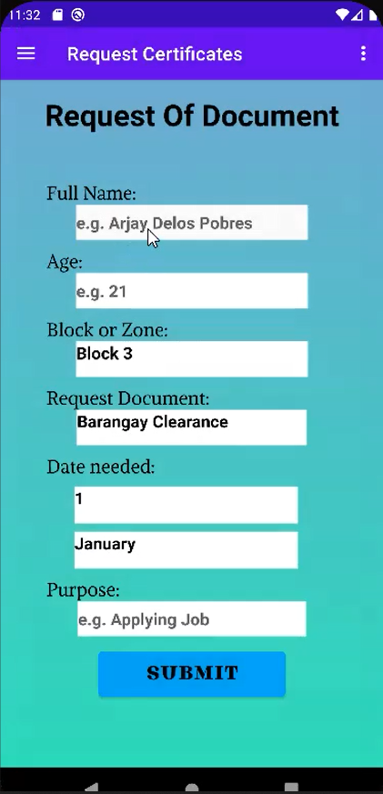

**ABOUT BARANGAY**

THIS IS THE INFORMATION OF THE BARANGAY YOU CAN SEE THEIR CONTACT NUMBER, REQUESTING DOCUMENT

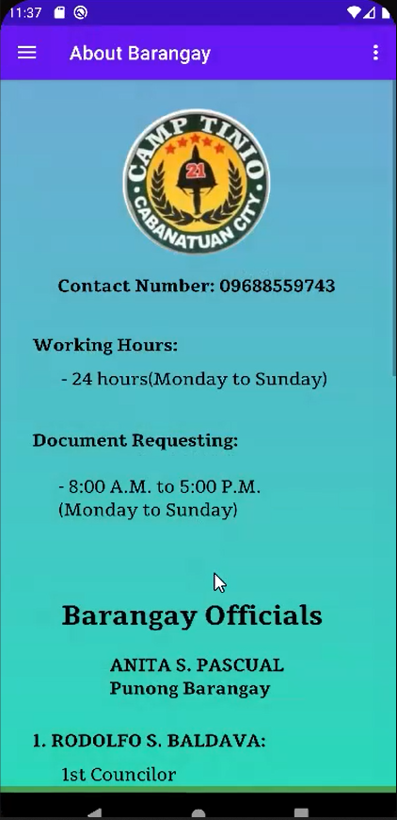

**DEVELOPER**

THIS ARE THE DEVELOPERS

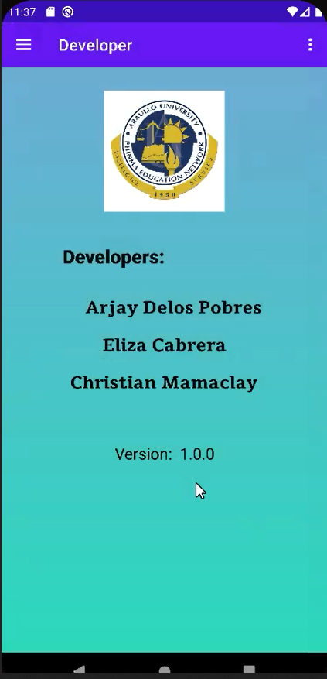

**TERM AND CONDITION**

THIS IS THE TERM AND CONDITION OF THE MOBILE APPLICATION

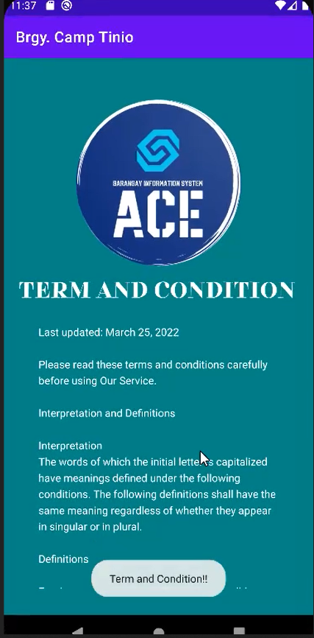

**PASSWORD RESET**

TYPE YOUR EMAIL TO MAKE YOUR PASSWORD RESET AND CLICK RESET

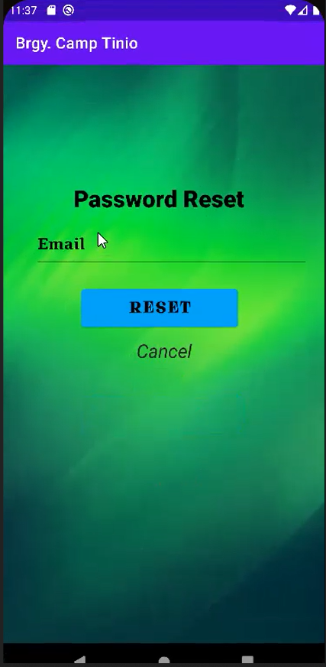

**PASSWORD RECOVERY**

AFTER YOU CLICK RESET GO TO YOUR GMAIL IN YOUR GMAIL IT WILL SEND THEPASSWORD RECOVERY AND CLICK IT

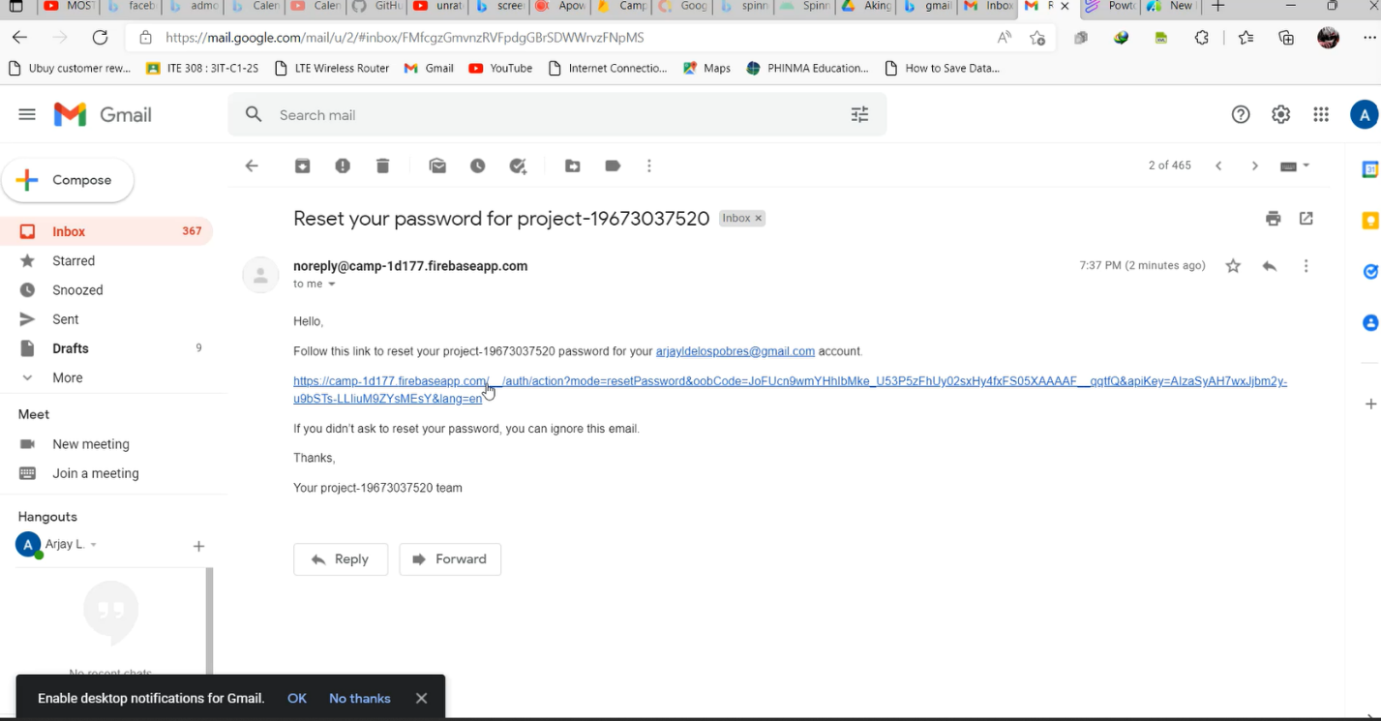

**INPUT OF RECOVERY PAASSWORD**

AFTER YOU CLICK THE RECOVERY PASSWORD USERS CAN CREATE NOW NEW PASSWORD AND CLICK SAVE

